**Project Report**

# 

# CAMPUS NETWORK DESIGN USING CISCO

# PACKET TRACER

A COURSE PROJECT REPORT

By

**Shashwat Prasad [RA2111026010143]**

**Roshan Priyadarshi [RA2111026010139]**

**Munshi Afroze Alam [RA2111026010142]**

**Mehak Agrawal [RA2111026010152]**

**Harshitha Nunna [RA2111026010154]**

*Under the guidance of*

**Dr.B. Hariharan**

(Associate Professor, CINTEL Department)

**In partial fulfillment for the award of the degree of**

**BACHELOR OF TECHNOLOGY**

In

**COMPUTER SCIENCE ENGINEERING**

**With specialization in Artificial Intelligence & Machine Learning**

Of

**FACULTY OF ENGINEERING AND TECHNOLOGY**



**S.R.M. Nagar, Kattankulathur, Chengalpattu District**

April, 2023

**SRM UNIVERSITY**

(Under Section 3 of UGC Act, 1956)

**BONAFIDE CERTIFICATE**

Certified that this project report titled “**CAMPUS NETWORK DESIGN USING CISCO PACKET TRACER**” is the bonafide work of “**SHASHWAT PRASAD [RA2111026010143], ROSHAN PRIYADARSHI [RA2111026010139], MUNSHI AFROZE ALAM [RA2111026010142], MEHAK AGRAWAL [RA2111026010152] & HARSHITHA NUNNA [RA2111026010154]**”, who carried out the project work under our supervision. Certified further, that to the best of our knowledge the work reported herein does not form any other project report or dissertation based on which a degree or award was conferred on an earlier occasion on this or any other candidate.

**SIGNATURE**

**Dr.B. HARIHARAN**

Assistant Professor

CINTEL Department

**TABLE OF CONTENTS**

|  |  |  |
| --- | --- | --- |
| **Sr.No.** | **TITLE** | **PAGE No.** |
| **01.** | **Abstract** | **05** |
| **02.** | **Acknowledgement** | **06** |
| **03.** | **Introduction** | **07** |
| **04.** | **Problem Statement** | **08** |
| **05.** | **Literature Review** | **09-11** |
| **06.** | **Work Done** | **12** |
| **07.** | **Device Used in The Network** | **13** |
| **08.** | **Implementation** | **14** |
| **09.** | **Configuring IP Address** | **15-21** |
| **10.** | **Topology** | **22** |
| **11.** | **Simulation** | **23** |
| **12.** | **Ping Test** | **24** |
| **13.** | **Conclusion** | **25** |

**ABSTRACT**

Computer networks have a significant impact on the working of an organization. Universities depend on the proper functioning and analysis of their networks for education, administration, communication, e-library, automation, etc. An efficient network is essential to facilitate the systematic and cost-efficient transfer of information in an organization in the form of messages, files, and resources. The project provides insights into various concepts such as topology design, IP address configuration, and how to send information in the form of packets to the wireless networks of different areas of a university.

The aim of this project is to design the topology of the campus network using the software Cisco Packet Tracer with the implementation of wireless networking systems.

This university network consists of the following devices:

1) Router (1941)

2) Switches (2960-24TT)

3) DNS server

4) WEB server (HTTP)

5) PCs

6) Laptops

7) Printer

The design includes the following parts of the University:

• Internet Lab

• Computer Department

• IT Department

• Server Room

• Principal Room

• Other

**ACKNOWLEDGEMENT**

We express our heartfelt thanks to our honourable **Vice Chancellor Dr. C. MUTHAMIZHCHELVAN**, for being the beacon in all our endeavours. We would like to express my warmth of gratitude to our **Registrar Dr. S. Ponnusamy,** for his encouragement. We express our profound gratitude to our **Dean (College of Engineering and Technology) Dr. T. V. Gopal,** for bringing out novelty in all executions. We would like to express my heartfelt thanks to Chairperson, School of Computing **Dr. Revathi Venkataraman,** for imparting confidence to complete my course project. We wish to express my sincere thanks to **Course Audit Professor Dr. Annapurani Panaiyappan, Professor and Head, Department of Networking and Communications** and **Course Coordinators** for their constant encouragement and support. We are highly thankful to my Course project Faculty Dr.B. **Hariharan, Associate Professor, Cintel,** for his/herassistance, timely suggestion, and guidance throughout the duration of this course project. We extend my gratitude to our **HoD Dr.R. Annie Uthra, Professor & Head, Cintel** and my Departmental colleagues for their Support.

Finally, we thank our parents and friends near and dear ones who directly and indirectly contributed to the successful completion of our project. Above all, I thank the almighty for showering his blessings on me to complete my Course project.

**INTRODUCTION**

The word “digital” is very significant in today’s world, with an increase in the development of technology the entire world is moving towards the digital era. The educational institution plays an important role in this digitalization; hence the campus should adapt to digital means of networking as well and become a “digital campus”. Going wireless plays an important role in this digitalization. The wireless network makes the connection easy with a reduction in the use of wires or cables. A wired connection makes it difficult to keep track of all the devices and to manage the cable connection, which is not only chaotic but also challenging to handle.

Campus networking via wireless connection becomes an important part of campus life and provides the main way for teachers and students to access educational resources, which gives an important platform to exchange information. As laptops and intelligent terminals are widely used, demand for access to information anytime and anywhere has become more and more urgent, but traditional cable networks cannot meet this requirement. Then wireless network construction becomes necessary and essential. The wireless network is one of the important components of a digital campus and wisdom campus. It provides an efficient way to explore the internet with a mobile terminal for teachers and students regardless of cables and places.

This is an important mark of the modern campus as a supplement of a cable network. With the development of network and communication technology, cable networks on a university campus bring much convenience for teaching and research work. But for mobility and flexibility, it has obvious shortcomings. A wireless network can overcome these drawbacks and has been applied to the university campus.

**PROBLEM STATEMENT**

In this mini-project, we defined a simulation of campus networks based on networking. The network is divided into six sets: Internet Lab, Computer Department, IT Department, Server Room, Principal Room & Other.

The major aim of this project is to show the connectivity that is used in campus to make the network efficient. Mobility is the major concentration of this project. In order to provide equal functionality to all the users (college staff and students), we have added DNS and HTTP servers for the maximum utilization of resources.

Designing a topology of a network that is a LAN (Local Area Network) for a university in which various computers of different departments are set up so that they can interact and communicate with each other by interchanging data. To design a networking scenario for a university which connect various departments to each other’s, it puts forward communication among different departments

**LITERATURE REVIEW**

● What is Packet Tracer?

Packet Tracer is a cross-platform visual simulation tool designed by Cisco Systems that allows users to create network topologies and imitate modern computer networks. The software allows users to simulate the configuration of Cisco routers and switches using a simulated command-line interface. Packet Tracer makes use of a drag-and-drop user interface, allowing users to add and remove simulated network devices as they see fit. The 8 software is mainly focused on Certified Cisco Network Associate Academy students as an

educational tool for helping them learn fundamental CCNA concepts. Previously students enrolled in a CCNA Academy program could freely download and use the tool free of charge for educational use.

● Router

A router is a device like a switch that routes data packets based on their IP addresses. The router is mainly a Network Layer device. Routers normally connect LANs and WANs together and have a dynamically updating routing table based on which they make decisions on routing the data packets. Router divides broadcast domains of hosts connected through it.

● Switch

A network switch (also called switching hub, bridging hub, officially MAC bridge is networking hardware that connects devices on a computer network by using packet switching to receive and forward data to the destination device. A network switch is a multiport network bridge that uses MAC addresses to forward data at the data link layer (layer 2) of the OSI model. Some switches can also forward data at the network layer (layer 3) by additionally incorporating routing functionality. Such switches are commonly known as

layer-3 switches or multilayer switches.

● Network Packet

A network packet is a formatted unit of data carried by a packet-switched network. A packet consists of control information and user data, which is also known as the payload.

● Server

A server is a computer or system that provides resources, data, services, or programs to other computers, known as clients, over a network. In theory, whenever computers share resources with client machines, they are considered servers. There are many types of servers, including web servers, mail servers, and virtual servers. Many networks contain one or more of the common servers. The servers used in our project are as follows:

➢ DNS Server

DNS stands for Domain Name System servers which are application servers that provide a human-friendly naming method to the user computers in order to make IP addresses readable by users. The DNS system is a widely distributed database of names and other DNS servers, each of which can be used to request an otherwise unknown computer name. When a user needs the address of a system, it sends a DNS request with the name of the desired resource to a DNS server. The DNS server responds with the necessary IP address from its table of names.

➢ WEB Server

One of the widely used servers in today’s market is a web server. A web server is a special kind of application server that hosts programs and data requested by users across the Internet or an intranet. Web servers respond to requests from browsers running on client computers for web pages, or other web-based services.

➢ FTP Server

FTP servers are the storage mechanisms that provide the secure transfer of files of varying weights and file formats. On-premises FTP servers will remain a component for large organizations managing complex and mission-critical file transfer requirements – but the trend towards cloud-based FTP servers is clear.

● Ethernet

This is the backbone of our network. It consists of the cabling and is typically able to Transfer data at a rate of 100mb/s. It is a system for connecting several computer systems to form a local area network, with protocols to control the passing of information and to avoid simultaneous transmission by two or more systems. Among the different types of ethernet, we have used Gigabit Ethernet, which is a type of Ethernet network capable of transferring data at a rate of 1000 Mbps and fast Ethernet is a type of Ethernet network that can transfer data at a rate of 100 Mbps.

● Computing Device

Computing devices are the electronic devices that take user inputs, process the inputs, and then provide us with the end results. These devices may be Smartphones, PC Desktops, Laptops, printer, and many more.

● Internet Protocol

Internet Protocol (IP) is one of the fundamental protocols that allow the internet to work. IP addresses are a unique set of numbers on each network and they allow machines to address each other across a network. It is implemented on the internet layer in the IP/TCP model.

● Simulation Environment

The simulations of our network topology can be easily achieved using cisco packet tracer. Using a simulation mode, you can see packets flowing from one node to another and can also click on a packet to see detailed information about the OSI layers of the networking. Packet Tracer offers a huge platform to combine realistic simulation and visualize them simultaneously. Cisco Packet Tracer makes learning and teaching significantly easier by supporting multi-user collaboration and by providing a realistic simulation environment for

experimenting with projects.

**WORK DONE**

In order to make our project understandable, we have divided the content into steps. They are

as follows:

1. Software and hardware requirements:

Before heading towards the implementation, we need to make sure of the following requirements.

● A proper workstation (any mid-high range laptop will suffice).

● Packet Tracer by Cisco

● 8 GB RAM.

● Any 10,000+ Average CPU Mark scored processor.

● 16 GB of dedicated hard disk space.

● USB 3.0+ port.

2. Network Requirements:

The network is divided into 6 areas:

1. Internet Lab

2. Computer Department

3. IT Department

4. Principal Room

5. Server Room

6. Other

**DEVICES USED IN THE NETWORK**

|  |  |
| --- | --- |
| Devices | Quantity |
| 1) Router (1941) | 3 |
| 2) Switches (2960-24TT) | 6 |
| 3) DNS server | 1 |
| 4) FTP server | 1 |
| 5) WEB server | 1 |
| 6) PCs | 12 |
| 7) Laptops | 1 |
| 8) Printer | 4 |

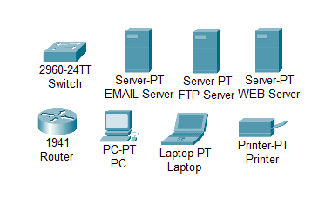

DNS

**IMPLEMENTATION**

● To design the network of the campus we initially started by placing the core devices into the frame as mentioned in the layout.

● Firstly, we placed the main router at the center of the campus outline,

which was further connected to the server switch using the gigabit ethernet

port with copper straight-through cable and sub routers using the serial port with serial DCE cable.

● The server switch was further connected to the DNS, FTP, and WEB

servers respectively.

● Router was connected to the campus switch which was further

connected with another two router that connects department and rooms.

● Connection to computing devices (PCs, laptops, and printers).

● All these connections are made through ethernet ports (gigabit ethernet and

fast ethernet) using copper straight-through cables.

**CONFIGURING IP ADDRESS**

We have attached the screenshots of all the IP configuration below:

* Router0:

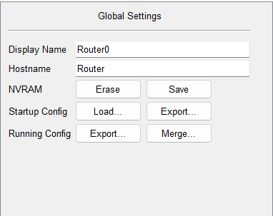

FastEthernet0/1

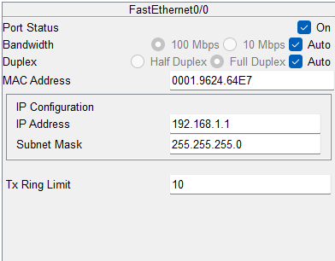

FastEthernet1/1

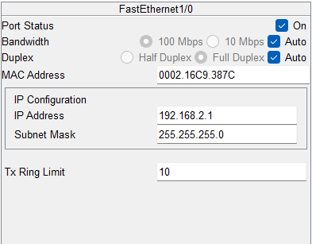

Serial2/0

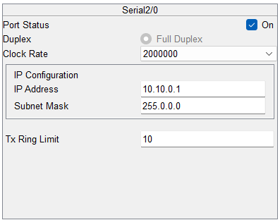

RIP

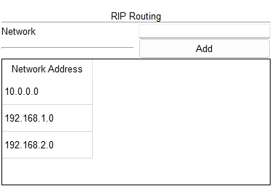

* Router1:

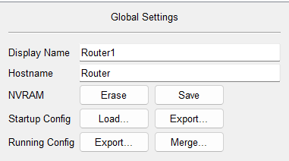

FastEthernet0/1

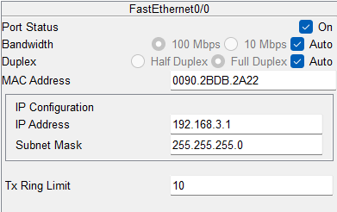

FastEthernet1/1

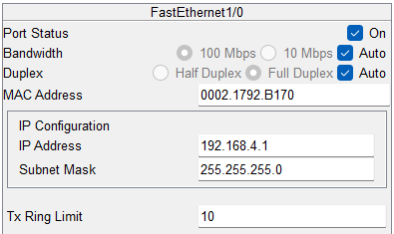

Serial2/0

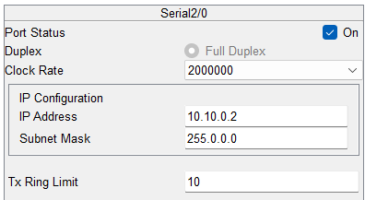

Serial3/0

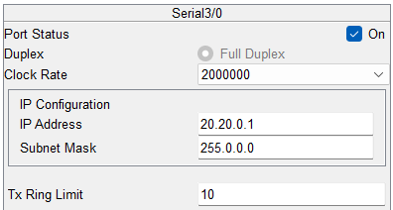

RIP

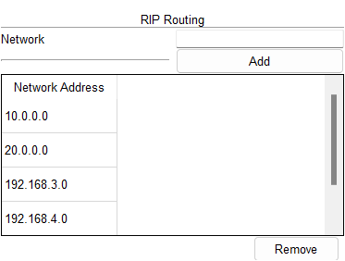

* Router2:

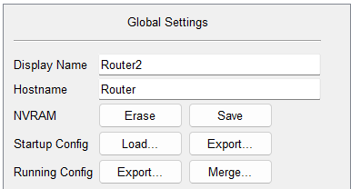

FastEthernet0/1

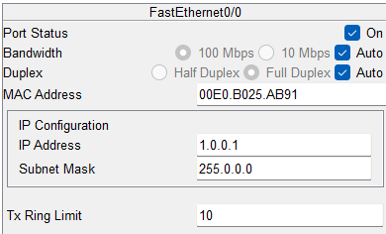

FastEthernet1/1

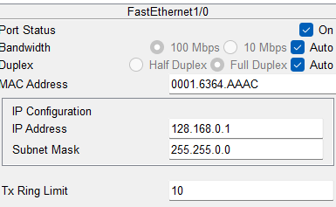

Serial2/0

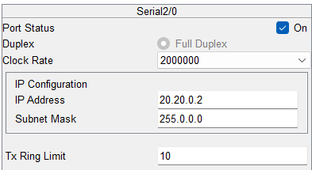

* DNS Server:

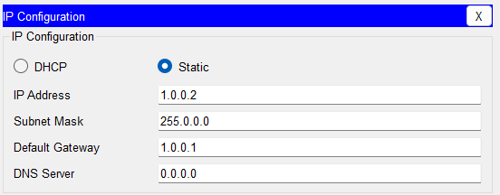

* WEB Server:

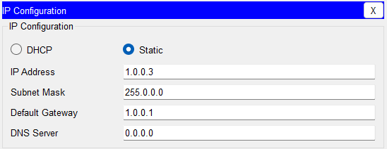

* FTP Server:

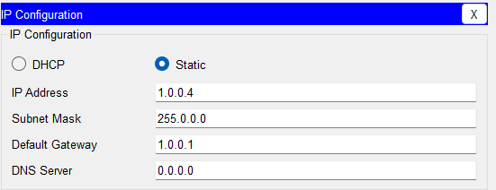

* Internet Lab:

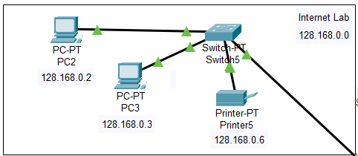

* Server Room:

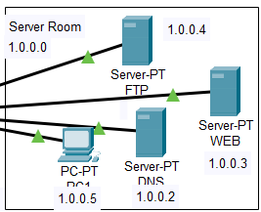

* Principle Room:

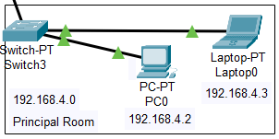

* Computer Department:

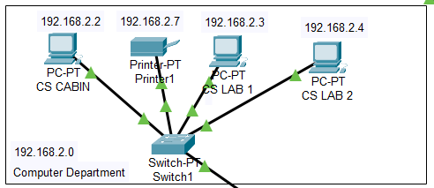

* IT Department:

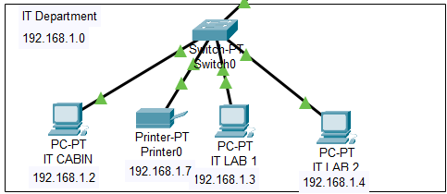

* Other:

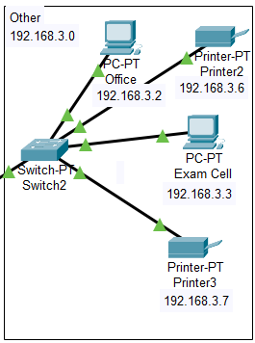

**TOPOLOGY**

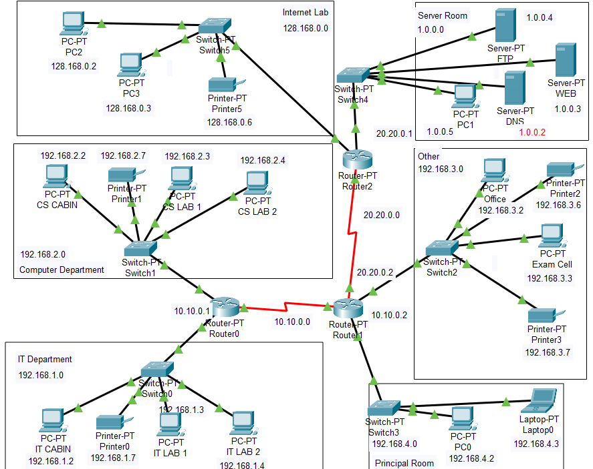

**SIMULATION**

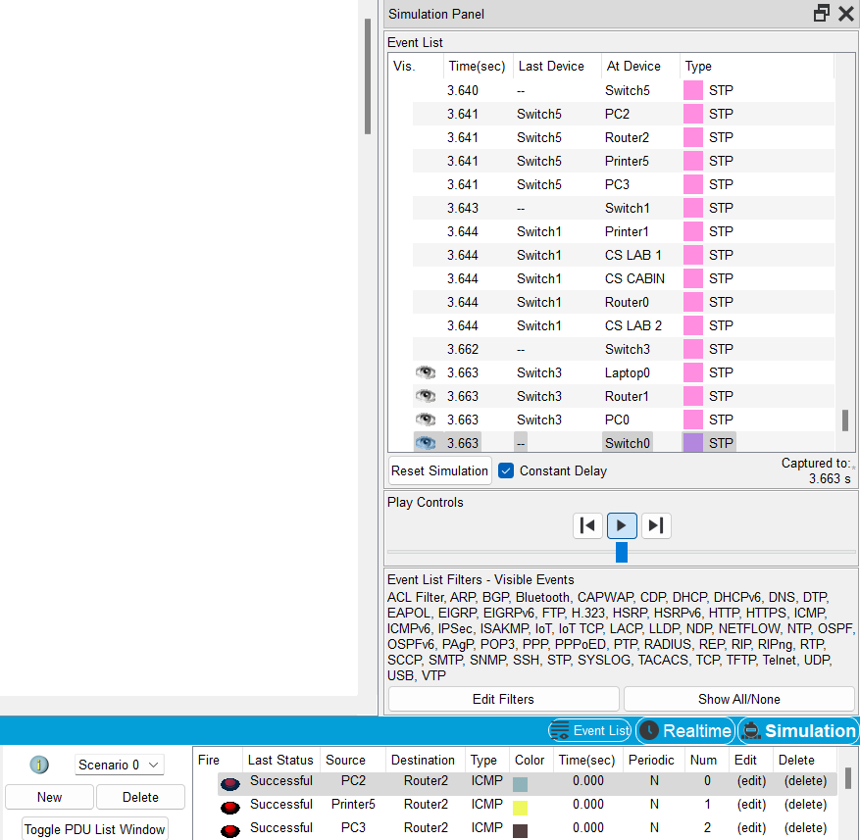

**PING TEST**

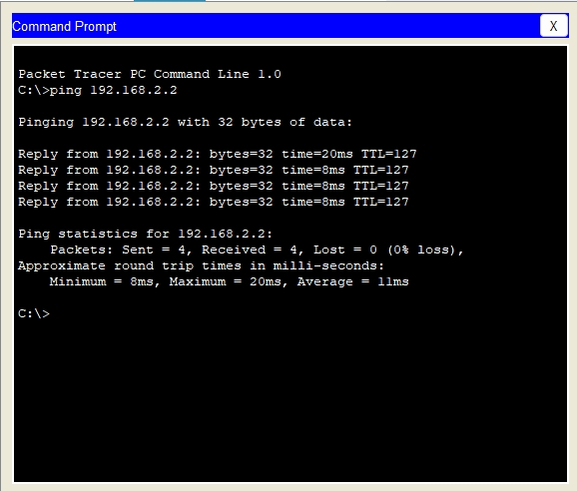

**CONCLUSION**

We started our discussion with the word “digitalization” and in order to achieve it, we aimed to start with an educational institute, and finally, we designed a network for a university, which is wireless. As we mentioned, mobility and efficiency are the key aspects of wireless networks, which were our main goal, and hence, we decided to shift to a wireless network instead of a wired one, making our network clean and less chaotic.

In this project, we designed a University Network using Cisco Packet Tracer

that uses a networking topology implemented using servers, routers, switches, and end devices in a multiple area network. We have covered all the necessary features that are required for a network to function properly. We have included a DNS server and a web server for establishing a smooth communication system between different areas of our network and specifically for the communication between students and teachers.

**THANK**

**YOU**